Socket Communication Demo Software Instructions

**1.** **Introduction of software interface**

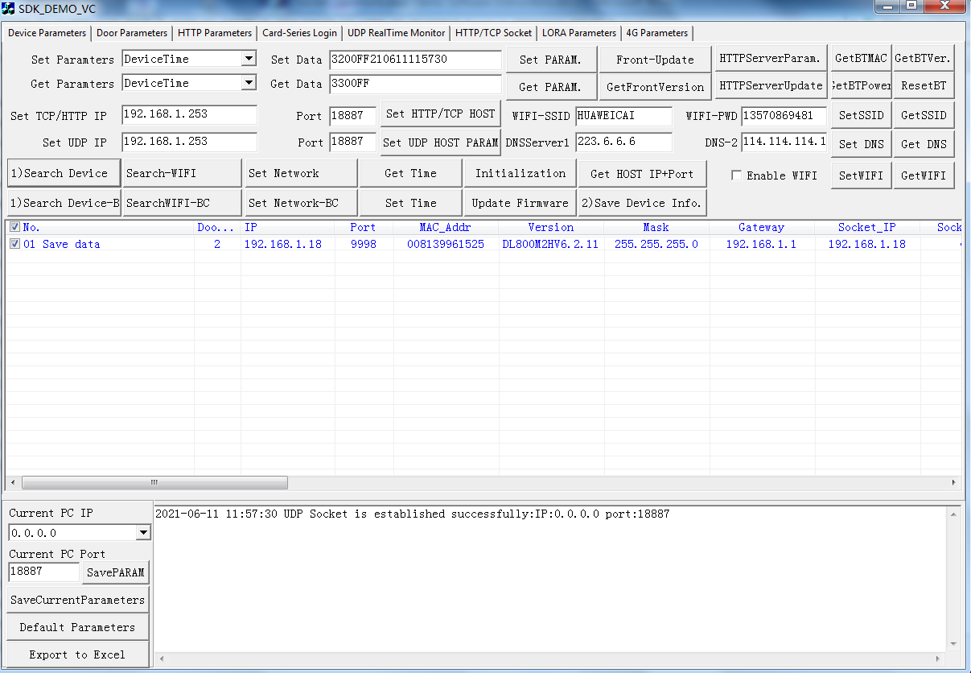

1.1 Function interface description：

1) Page 1: Device search and common parameter setting and reading

2) Page 2: Door parameters

3) Page 3: HTTP parameters

4) Page 4: Card-series Login

5) Page 5:UDP real time monitoring

5) Page 6: HTTP / TCP Server Real time monitoring

6) Page 7: parameter setting of LORA module

7) Page 8: parameter setting of 4G module

**2. Page 1 :Description of "Device search and parameters" interface**

**2.1 concept name or term description**

1) "Local PC IP": if the local machine has multiple network cards, such as Ethernet, WiFi network, multiple Ethernet cards, or multiple IP addresses of an Ethernet card. This drop-down list will display all IP addresses of the local computer.

Special IP address Description:

(1) IP：0.0.0.0

If the IP address 0.0.0.0 is used as the communication IP address first, it means that no matter which network card sends data, it will be sent to this IP address. This is a general IP

(2) IP：127.0.0.1

This is an IP address of the local network card when the Ethernet card of the computer is not plugged in. It is useful for debugging the software of the local computer. If you want to communicate with the external device, it will not work. If there is no network cable when starting socket software, and then plug in the network cable after starting, you need to restart the software at this time, so as to get the correct local IP address

Note: the socket IP address needs to be selected correctly. In addition to 0.0.0.0 IP address, the selected IP address must be in the same network segment as the IP address of the device to communicate. If you change the "local communication IP address", you need to restart the software.

2) "Save current parameters": this function button actually saves all the values of the interface edit box, so as not to restore the previous default values after exiting the software. For example, after you modify the IP address of "Set HTTP / TCP IP", click "save current interface parameters" to enter the software next time.

3) "Default parameters": when you don't know whether the input value is correct, click this function button, the software will display the default parameters in the corresponding position of the interface for your reference。

2.2 Function description

1)“Search Device”/“Search Device BC”

After entering the software, you have to search the device to set and control the parameters of the device. To search for devices with broadcast command is actually to send the IP address of the search command, "255.255.255" or the specified IP network segment, and the last IP network segment IP is 255, such as "192.168.1.255", which is a kind of broadcast address. Broadcast command, no matter what the IP address of the device is, no matter how many "local communication IP address" is selected, can send the command to the access control device, and the access control device will feedback the command back. But some win10 operating systems will block the transmission of broadcast commands. Disable the broadcast command.

When using the "Search Device " or " Search Device BC " command to search for a device, you should pay attention to the following aspects:

Whether the computer IP address and the device IP address are in the same network segment. The same network segment means that the first three IP network segments of IP address are the same, but the last IP network segment is different. For example, the default IP address of the device is 192.168.1.15. If the computer IP is not 1 network segment IP, your Ethernet network card be needed to add 1 network segment IP, such as 192.168.1.253 IP.

How to get the IP address, mask, gateway and other information of this machine, you need to enter the DOS command line state. In the windows interface, "start" button, enter "CMD", enter to confirm, enter the DOS command window, enter "ipconfig / all" enter

After then, Search for network devices should come out with device parameters, as shown in the figure below, search for two devices, and then click the "save table device information" button。

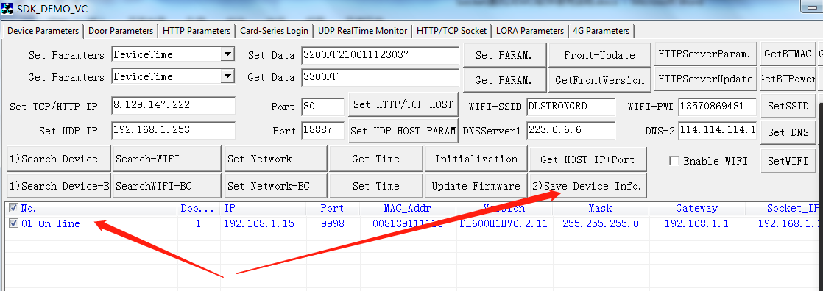

2) Set TCP / HTTP server’s IP and port

The software platform is the server, and the device is the client. Whether it is TCP mode or HTTP mode, the device actively connects to the server, so the IP address and port of the server computer (or cloud computer) must be set. Software port and server IP, you need ask your software R.D.developers。

3) Set UDP server’s IP and port

UDP communication is an unreliable way of communication, generally used in LAN, and UDP has a convenient place is to broadcast communication, it do not need to establish a connection can send data in advance. Socket software itself is UPD communication, convenient to search or set parameters. UDP communication does not affect TCP / HTTP communication. The device will send data to UDP server and TCP / HTTP server at the same time

4) Get server IP and port parameters

Click “Get HOST IP+Port ” button to get the TCP / HTTP server IP and port set in the device, and also get the UDP server IP and port information, which will be displayed in the list. It is convenient for multiple devices to check whether there are errors or omissions in server parameters。

5)”Get Time” and ”Set Time”

This is the time to set or read the ticked devices. Setting time refers to setting the computer time into the device for time correction.

There is a clock holding circuit in the device. Even if the power is off for 1-2 weeks, the clock will keep running

6) “Set Network” and “Set Network-BC”

Check the device to be set and click "Set Network" to modify network parameters

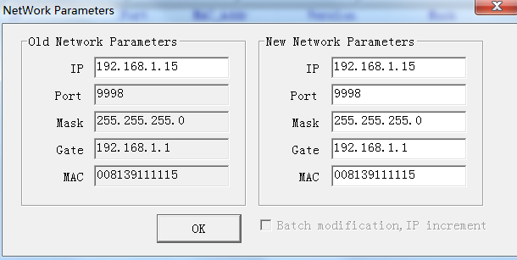

The left side is to set the original network parameters (IP address, gateway, mask), etc., and the right side is to modify the network parameters

For example, if you want to modify the IP and gateway, you can fill in the modified parameters. The MAC address is generally not modified. It remains the same as the previous MAC address. The MAC address needs to be unique in the LAN, just like the IP address. The exchange information stored in the switch or router is Mac and IP. If there is a duplication of MAC in the LAN, There will be something wrong with network communication. if you want to modify the MAC address, you must pay attention to the fact that the first byte of the MAC address must be even (fill in the odd number, then the device is the multicast address, and the router will prohibit the multicast address), generally fill in 00

If there are multiple devices that need to modify IP address parameters, first check the multiple devices that need to be modified, then right-click and select "modify and check device IP". In the network modification dialog box, check "batch modify and IP increment". That is, after modifying the first device’s network parameter, and other device are same as first deivce,except IP address increment, the function is convenient for batch modification. As shown in the figure below：

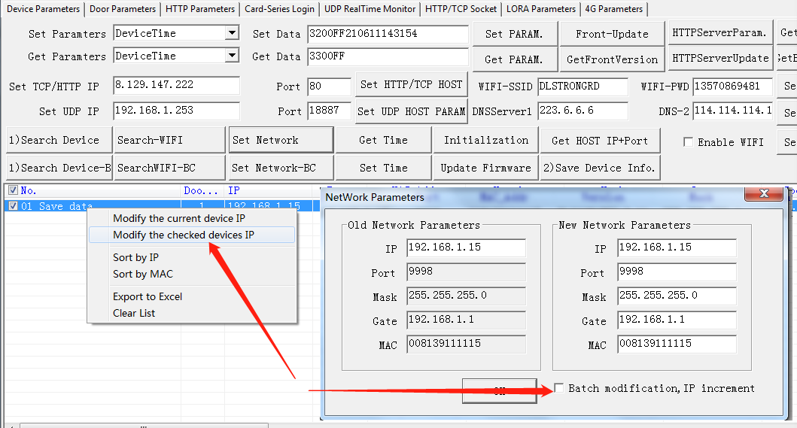

7) SET WIFI SSID and Get WIFI SSID

SSID is the name and password of WiFi AP.

8)Set DNS and Get DNS

DNS is a DNS server, that is, a domain name server. If domain name resolution is not used, this parameter can be ignored.The default DNS servers of the device are 223.6.6.6 and 114.114.114.114。

9) Enable or disable WIFI and Get WIFI enable Status

After WiFi is enabled, device data will be transmitted from WiFi instead of RJ45 in TCP or HTTP mode. But it does not affect UDP communication

**3.“Door parameters”** **Interface description**

Some devices can control multiple doors, such as two door controller, which can control two doors at the same time. Generally, the “All in one” device only has the parameter of door 1, some “All in one” devices also have two-relay output, and can also set the parameters of door 1 door 2

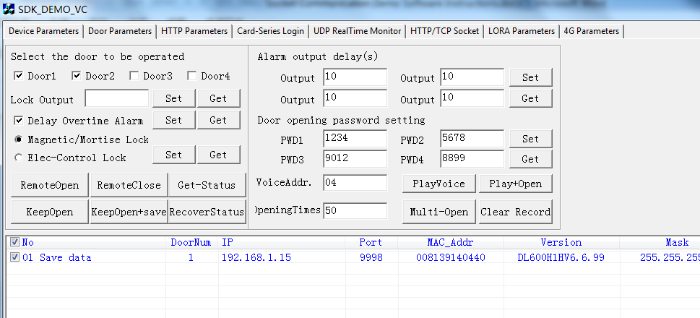

1. Remote Open

send commands to the device that checked in the list, “Remote Open” can control door opening, can control from door1 to door4

2）Remote Close

“Remote Close”，the function just reset the relay delay to zero. The action of closing the door can only be performed by the door closer. If the delay of the relay returns to zero, the door lock will automatically lock the door。

3）Keep Open

“Keep Open”, The relay is always in the closed state, so that the door lock is not powered, and the door can not be closed, but after the device is restarted, the door normally open command is invalid。

4）Keep Open+Save

The relay is always in the closed state, so that the door lock is not powered, and the door cannot be closed. After the device is restarted, Door lock still not powered。

5）RecoverStatus

After executing “Keep Open” command, and then executing "RecoverStatus", the door state will be restored。

6）Lock Output Delay

This parameter is the closing time of the control relay (seconds)，default is 3 seconds

7）Lock type

Power off lock (magnetic lock or electric bolt lock), the type of lock that is opened after power off

Power on lock (electric control lock), power on pulse can control the lock to open the door, when power off,the lock does not open, This kind of lock has a key, and can use key to open door.

8）Door Ppassword

Some devices have the password function. The default password length is 4 digits, such as 1234. The password operation is as follows: press the 1, 2, 3 and 4 number keys, and then press the "#" key to confirm the password. Press the "*" key to cancel the current input and re-enter. You can also enter more than 4 passwords, and then press the "#" key, such as "1,2,3,4,5,6", and then press the "#" key, the device will send "123456" to your server to check

9)Play Voice/Play Voice+Open

Voice address refers to a voice address corresponding to one voice. For specific speech and address information, see the voice address table. For example, address 04, corresponding voice "please enter". Multiple voice addresses can be input simultaneously, for example 01020304, it means that it will play: address 04 corresponds to voice + 03 address corresponds to voice + 02 address corresponds to voice + 01 address corresponding voice.

Play Voice+Open, means that remote door opening and voice playing function at the same time.

10)Clear Record

Clear all record in the device

**4.“HTTP Parameters” Interface description**

HTTP communication protocol is essentially TCP communication, but the data content of communication is visible ASCII characters. HTTP protocol is mainly HTTP header parameter and HTTP post content (HTTP body). HTTP transmission mode includes get and post. The device adopts post transmission mode。

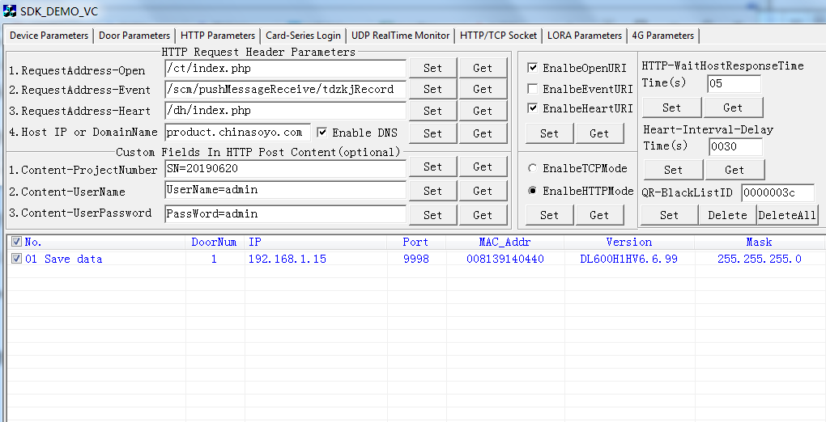

HTTP has three API interfaces: One is to request the opening address; Second, record the upload address; Third, the heartbeat address. For example, the following HTTP data

POST /verify/Opendoor HTTP/1.1

Host: 112.74.87.63:8039

Content-Type: application/x-www-form-urlencoded

Content-Length: 82

Type=1&SCode=857561060029&DeviceID=008806996230&ReaderNo=1&ActIndex=1&OpenEvent=00

“POST” The HTTP transmission mode is post mode

“/verify/Opendoor” It's a request to open the door

“Host: 112.74.87.63:8039” "112.74.87.63" in is " host IP address or domain name parameter", and port parameter is the port parameter of "setting http / TCP server" in "device search and parameters" interface。

Note: if the QR code contains ‘&’ characters, and if platform software uses & as field separator, the segmentation error software needs to correct this problem. It is recommended to search the field by string search, such as "search" &score= "", "&deviceid=" string to get the field content, which will be accurate.

1) Request to open the door API address: the URI path of the device request to open the door。

When the device has events such as scanning, swiping card and password, the device actively uploads data to the HTTP server.

2) Record upload API address: URI path of device record upload

When the device generates records, such as remote door opening and QR code door opening when leaving, records will be generated. If the records are uploaded 20 at a time, if less than 20, all the remaining records will be uploaded. After uploading to the platform, the platform needs to respond to receive the records, and then the device will upload the next batch of records。

3) Heartbeat upload API address: URI path of device heartbeat upload。

The function of heartbeat API is to indicate that the device uploads data to the platform regularly. The platform can sense the normal state of each device and indicate that the device is connected to the network. The heartbeat can be calibrated time, and the heartbeat can also download the card series, but after the software gets the heartbeat information, it can download the card series. After the device receives the download card field, it will store the card series to the device, and immediately upload the heartbeat information again to tell the platform whether the card download is successful or not. After the platform gets the download card successfully, it can download it again, so as to fully meet the needs of the card download。

4) Host IP or domain name

Here, you can only fill in the domain name or IP, not the port. Do you want to bring "http: / /", for Example, IP: 192.168.1.253, Domain name: www.baidu.com , the port of the software, and the port in "set http / TCP server" on the first page, so don't forget to set the IP and port of "http / TCP server" in the HTTP mode on the first page. If domain name resolution is enabled, the IP of "http / TCP server" can be specified at will, and the device will resolve the IP address corresponding to the domain name according to the set domain name, To replace the IP address in the HTTP / TCP server parameter

5) Enable 3 HTTP API

All three API are enabled by default，However, someone do not need to enable the "Request to open" API or " Record upload" API

6) Enable TCP mode or HTTP mode

TCP communication is generally a basic communication protocol and the data is hexadecimal. Therefore, TCP communication is the most compact and fast. After connecting to the server, TCP is constantly open. So TCP server can send communication commands to devices at any time, such as remote open door command。

The HTTP communication mode is based on TCP communication, but the application is encapsulated, generally uploading visual characters. Of course, body content can also be data stream. HTTP is a short connection mode. Generally, after a command interaction is completed, the connection is disconnected.

The device defaults to HTTP mode. If you need to switch, this function is to switch to HTTP communication mode or TCP communication mode.

The two function keys of "set" and "get" are actually to read whether the device is in HTTP mode or TCP mode. If they do not meet their own requirements, they can also be set

7) HTTP waiting delay time for host response

When the three HTTP API are uploaded to the server, it is necessary to wait for the server to respond. This wait time is "HTTP wait host response time". If the waiting time exceeds this time, the device will no longer wait and disconnect automatically. For example, brush QR code, and the device uploads QR code to HTTP server platform in format. After the waiting time is exceeded, the device will no longer wait for the response of the server, and the connection will be disconnected. HTTP default wait time is 5 seconds

8) Heartbeat interval

HTTP or TCP communication mode, need to upload heartbeat information. Heartbeat information, in fact, tells the server platform that the device is always connected to other devices. There is an interval for uploading heartbeat information, which is 30 seconds by default. However, users can set the upload time of heartbeat information according to the scene, and the time range is 3-3600 seconds

**5.“UDPRealtime Monitor” Interface description**

When the UDP server IP and port of the device are the same as the computer IP of the machine and the port of demo software, the swipe card, scan QRcode and timed heartbeat information of the device will be uploaded to this interface for display. This interface is divided into two representations, the above table is real-time data monitoring, real-time data is scan QRcode, swipe card, and heartbeat information real-time upload data. The following table is the record generated after the opening of the device itself. The record itself has the information of recording time, reading number, recording event number, etc. Generally used as attendance data. When the phenomenon is no open / close, you can use this form to determine the reason why there is no open / close

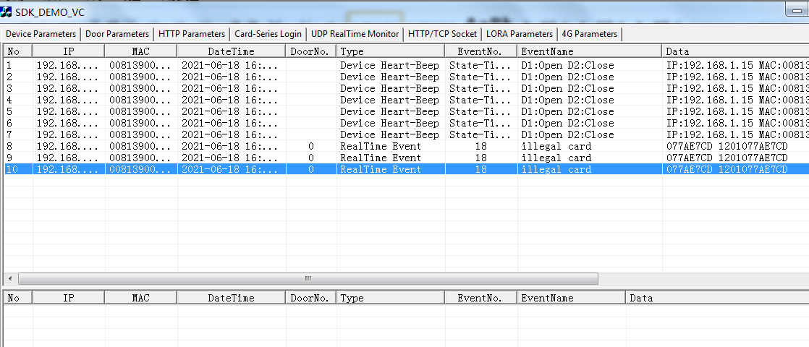

**6.“HTTP/TCP Socket” Interface description**

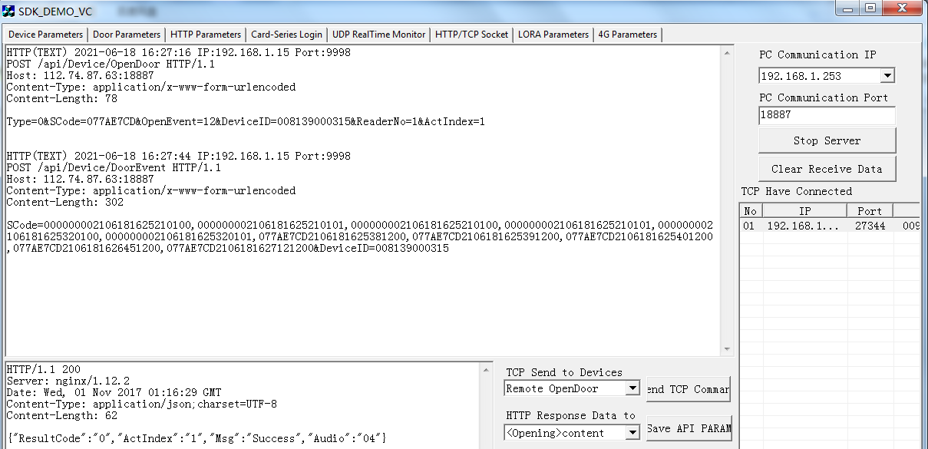

In this interface, you can operate the "Start server" button to make demo software set up a TCP / HTTP server. When the IP of the device's TCP / HTTP server is the local IP and the port is the same as the one just established, the device will connect to this server.

Swipe the card or QR code, you can see the data uploaded in this interface

If the device is in TCP mode, it will be indicated in the middle of the right side after the device is connected to the server. It will display the IP and other parameters of the connected server, indicating which devices are connected. Select a device, select " send TCP command", and then click "Send TCP command" button to send the command to the selected device. The device responds to this command

If the device is in HTTP mode, such as scan QR code, the device does not open the door because the QRcode string does not conform to the device’s Qrcode rules. However, after the demo software gets the QR code string, it will respond automatically. The data of the automatic response can be edited. After editing, click the "Save API PARAM" button on the right side, the data corresponding to the left editing box will be saved

**Table 1,** **Event No. and event name**

|  |  |  |  |  |  |  |  |  |  |
| --- | --- | --- | --- | --- | --- | --- | --- | --- | --- |
| No. | Event Name | No | Event Name | No | Event Name | No | Event Name | No | Event Name |
| 0 | SwipeCardOpen | 1 | RemoteOpen | 2 | DualCardOpen | 3 | PasswordOpen | 4 | DuressPasswordOpen |
| 5 | InputSignalOpen | 6 | PrimaryCardOpen | 7 | ExitButtonOpen | 8 | DoorBeclosed | 9 | IllegalEnter |
| 10 | EnterSwipeCard | 11 | OutSwipeCard | 12 | TheStaffHasLeft | 13 | TimeLimit | 14 | InvalidPassword |
| 15 | InvalidDualCard | 16 | EmergencyOpen | 17 | NoBrushPrimary  Card | 18 | IllegalCards | 19 | DualCardSwipe |
| 20 | DoorDelayTimeOut | 21 | Duress Alarm | 22 | MultiCard combination is correct | 23 | CardExpired | 24 | InterlockingLimited |
| 25 | AlwaysOpenDoor | 26 | RemoteClose | 27 | UrgentOpen | 28 | UrgentClose | 29 | DoorIsClosedUrgently |
| 30 | AlwaysCloseDoor | 31 | RecoverDoorStatus | 32 | 3 CardSwipeCard | 33 | 4 CardSwipeCard | 34 | 5 CardSwipeCard |
| 35 | 3 CardIsInvilid | 36 | 4 CardIsInvilid | 37 | 5 CardIsInvilid | 38 | 3 CardOpen | 39 | 4 CardOpen |
| 40 | 5 CardOpen | 41 | 1 CardConfirmOpen | 42 | 2 CardConfirmOpen | 43 | 3 CardConfirmOpen | 44 | 4 CardConfirmOpen |
| 45 | 5 CardConfirmOpen | 46 | RepeatSwipeCard | 47 | CardExpired | 48 | RemoteConfirmOpen | 49 | WaitingforPassword |
| 50 | SystemNormalState | 51 | SystemIsFull | 52 | SystemOverMan | 53 | StaffHaveEntered | 54 | AreaError |
| 55 | DoubleOpenRecovery | 56 | DoublecloseRecovery | 57 | HandBoxDoubleOpen | 58 | HandBoxDoubleClose | 59 | HandBoxOpenDoor |
| 60 | HandBoxReset | 61 | LatchTongueError | 62 | LockErrorRecovery | 63 | DeletedCard. | 64 | KeyOpenDoor |
| 65 | RequestIntercom | 66 | AutomaticAddCard | 67 | RepeatEntry | 68 | RepeatOut | 69 | EffectiveDateInvalid |
| 70 | Q.R.Open | 71 | Q.R.TimesNotEnough | 72 | Q.R.Expired | 73 | Q.R.StartDateError | 74 | MAC.Mismatch |
| 75 | ProjectNo.Error | 76 | BuildingNo.Error | 77 | EncryptionKey IncorrectIncorrect | 78 | Q.R.LengthError | 79 | Q.R.DeviceExpired |
| 80 | MAC. QuantityError | 81 | Q.R.OtherErrors | 82 | FloorNo.Error | 83 | RoomNo.Error | 84 | FlatNo.Error |
| 85 | Q.R.TimeLimit | 86 | reserve | 87 | Reserve | 88 | Reserve | 89 | Reserve |
| 90 | CardTimerNotEnnumber | 91 | InputFfailure | 92 | DeviceBlacklistCard | 93 | DeviceLossCard | 94 | BlacklistCard |
| 95 | LossCard | 96 | CardTypeError | 97 | Reserve | 98 | Reserve | 99 | Reserve |